Fiji MCO CCA 2023 Summary_281123
Fiji

Key CCA takeaways

Fiji’s post-COVID recovery is well underway and is estimated to grow by 12.6% in 2022 on the back of strong tourism recovery with an expected 55% tourist arrivals to pre-pandemic level. Expected to recover to its pre-pandemic level by 2024 Fiji’s outlook hinges on tourism activity, impacts from the Ukraine war and the country remains vulnerable to external shocks—particularly natural disasters and the effects of climate change. Upcoming national elections will be an important part of the backdrop over the next year.
While the direct impacts of the Russian invasion of Ukraine is observed to be relatively small due to limited economic linkages with both countries and the wider European region, the Pacific including Fiji is experiencing indirect impacts from the war—through commodity prices, global growth prospects affecting major economic partners, and exchange rate movements. Since fuel constitutes 22% of Fiji’s total imports, international fuel price shocks generally translate into compounding impacts across most commodities. Despite inflation mitigation measures in the new 2022-2023 budget, Fijian continue to significant price increases in staple food items. Going forward, structural reforms are needed to accelerate growth and poverty reduction, and fiscal consolidation is critical to reduce the high level of public debt.
Fiji must rebuild its touristic offer with added value, including safety as a defining characteristic, and an essential investment in sustainability and greening the tourism sector given environmental impact concerns.
Fiji can and should maximize its demographic dividend and offer its youth a bright future. Harnessing the demographic boom is an essential component of economic, social, gender transformation for Fiji to recover from COVID-19 and achieve high income status in the future.
Fiji will need to continue nurturing labour mobility with neighbours and partners who open their borders to migrant workers, and with Fijian migrant workers themselves, preparing them for the future, offering opportunities to reskill.
Fiji must end the violence against its women and girls and the prevailing discriminatory attitudes to women that obstruct their full contribution to development. There is need for a clear national strategy to change cultural norms, unroot the deep causes of inequality and gradually modify the prevailing set of exclusionary cultural norms and attitudes that constitute mainstream thinking in Fiji and obstruct national progress under the 2030 Agenda.
Another developmental priority is to ensure that more women are given access to decision-making responsibilities, in the public sphere. There is a need to support women’s economic empowerment. This includes addressing women’s lower labour force participation rate; addressing the gender pay gap; improving the quality and conditions of informal work; supporting women owned MSMEs; increasing women’s access to finance; and addressing the high level of poverty amongst female headed households.
Child poverty remain a high concern despite overall progress. A programme for the next decades must make children living in poverty history in Fiji.
Social cohesion demands leaving no one behind and empowering. Those furthest behind require urgent attention: persons with disabilities, including persons with albinism. LGBTIQ persons. PLWHIV. Older persons have the right to a good life after their decades of work. Implementation of existing commitments as well as humanity and solidarity are needed to provide migrants and asylum seekers the treatment they deserve under international law.
Climate action is the companion policy of growth in the blue and the green economies, where protecting Fiji´s biodiversity, marine and coastal resources, forests, and seabed must be compatible with sustainably exploiting these natural endowments. Fiji's blue assets provide commercial and non-commercial opportunities that include subsistence fisheries, commercial fisheries, tourism, shipping, coastal protection, research and education, and carbon sequestration.
A future modern agriculture is part of this equation to increase Fiji´s comparative advantage in the production of environmental goods and services.
Facing a multitude of interconnected risks across sectors requires strengthened risk governance instruments. Managing vulnerabilities through systematic poverty reduction, social protection and welfare services is increasingly necessary in a context where livelihoods and lives of people are dependent on the environment and systems highly vulnerable to the impacts of climate change.
Digital transformation presents a significant avenue for progress on Agenda 2030 and on Fiji’s economic development. To this end significant investments are required in improving digital infrastructure and legal framework and policies. Fiji has the potential to develop smart cities and adopt modern urban management practices. Services, e-commerce and e-trade, e-Government, digital payment ecosystems, and enhanced government capacities, can be the result of education in digital literacy and skills.
These aspirations of economic transformation, just ecological transition and inclusive social cohesion will require innovative financing. Traditional ODA surge needs to accompany other means of implementation. The Fijian monetary authorities will need to continue borrowing to invest in urgent needs while watching the country´s levels of indebtedness and debt stress.
Most importantly, any development journey depends on the governance that steers it and on the protection of the human rights that represent its values. Fiji has a major opportunity to continue on the path of easing the tensions, continuing generating cohesion and equal opportunity. A better governance will also require increasing civic space and openness of State actors to interact with non-State actors, supporting Fijian civil society and human rights defenders, respecting its leadership, building trust, a two-way street and a reciprocal commitment.
And lastly, better disaggregated data according to the 10 main elements of non-discrimination are urgently needed for decision-makers in politics, investors and business leader.

PEOPLE

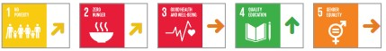
The most excluded populations in Fiji include children and youth, women and girls, women survivors of violence, persons with disabilities, persons living in urban, rural, and maritime settlements, older persons, single mothers, LGBTQI+ persons, sex workers, persons living in poverty, populace with limited access to technology and informal workers, among others.
On SDG 1, the poverty rate in Fiji has steadily decreased from 28.1% in 2013/2014 to 24.1. However, onset of COVID-19 and two severe
Category Five cyclones, poverty levels are likely to have increased further with the economic contraction and rise in unemployment. Fiji’s progress on SDG 2 continues to be insufficient in spite of moderate improvements. The proportion of the population suffering from hunger was 5.6% in 2018-20. The baseline on undernourishment, stunting and malnutrition reveals that it will take Fiji several more years to fully realise SDG 2.
Prior to COVID-19, food availability was not an issue of grave concern in Fiji, the main challenge for many Fijians was to afford or adopt a healthy diet. Food and nutrition security indicators has scarcely improved in decades.
The prevalence of food poverty is much higher in rural areas standing at 11.1%, while at 2.6% percent in urban areas, and was more prevalent in the Eastern division at 13.7% than elsewhere, according to the HIES 2019-2020.

Fiji has a net negative food trade balance. In 2015, just 32% of the country’s food was sourced domestically.
Gender equality remains a major challenge for Fiji. Only about 39% of women in Fiji aged 15 years and over are categorised as economically active, less than half the activity rate for men. Significant gender inequalities persist, manifested in unequal economic and political participation, protections, and benefit sharing. This is due in large part to the pervasive culture of discrimination against women that constitute mainstream thinking in Fiji.
Women are underrepresented in the paid workforce while overrepresented in family care roles, 26.5% of all landless households are headed by women and the majority of businesses owned by women in Fiji are in the informal sector.
Women are predominately driving the ‘care economy’, the sector responsible for the provision of care and services in families and society, where jobs are extensively unpaid or under-paid. Women’s rights advocates have identified policy and programmatic entry points and key tools transforming the care economy so as to promote women’s rights and gender equality, human development, and inclusive and sustainable growth.
In terms of women’s political participation, a recent analysis indicated that of 192 Board members in 38 Boards, women comprise only 21% of all Board members, and 42% of 38 Boards have no women at all. The percentage of female MPs increased from 16% to 21.5% between 1995 and 2014, and currently stands at just under 21.57%.
Furthermore, Fiji is facing an epidemic of violence against women and girls in both public and private spaces. One in five Fijian women has experienced sexual harassment in the workplace. Disaster and climate change impacts stand to exacerbate gender-based violence.
While welcoming the high rates of enrolment in Fiji, the CEDAW Committee expressed concern over the limited access to secondary and tertiary education for many rural girls, owing to poverty.
Children in Fiji are at risk of being left behind. 44% of children and youth (aged 0–14) are in poverty compared to 29.9% of the general population. Fijian children experience a range of protection rights violations, such as neglect, abuse and exploitation at home, at schools and in the community. Preliminary findings from the 2021 MICS indicate that 80.5% of children aged 1-14 years experienced physical punishment and/or psychological aggression by caregivers in the past month. The Committee on the Rights of the Child has urged Fiji to bring its juvenile justice system fully in line with the CRC by raising the minimum age of criminal responsibility to an internationally accepted level.
Families living in informal housing usually suffer the highest poverty levels of all geographical locations in Fiji, according to the Government´s official statistics. Driven by employment opportunities, real or perceived, and the possibility to better access public services, the country is experiencing a rapid internal migration
from rural areas to urban centres with 50% of the population residing in cities and towns and with one in four Fijians in urban areas living in informal settlements. “There are about 200 informal settlements in Fiji, home to approximately 15% of the population. Informal settlements often lie on the outskirts of cities and towns, have not been subject to zoning or subdivision plans and are particularly vulnerable to climate change. Most residents have migrated from outer islands or rural areas. Housing quality is poor, increasing vulnerability to climate-related natural disasters, and access to municipal services is limited, leading to pollution and health risks.”¹³
Although there has been notable progress in Fiji’s social protection systems over the past decade, they are still in need of further refinement, wider coverage, and additional resources, so that people living in poverty and other vulnerable populations, including children, are sufficiently protected.
Social protection initiatives such as the Poverty
Benefit Scheme, the Care and Protection
Allowance, the Social Pension Scheme, the
Disability Allowance and other safety nets of the Fijian Government play an important role in providing assistance to vulnerable Fijians to meet their basic needs. Interventions such as free water, subsidized electricity, free education, and free medicine and health services lighten the cost burden for many Fijian families. Their expansion would have a truly transformative effect on poverty and inequality.

PROSPERITY
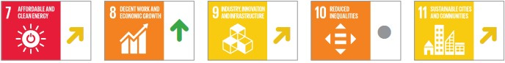

While Fiji was among the five hardest hit economies globally that experienced the sharpest contraction in GDP growth in 2020, recovery is well-underway with 2022 GDP expected to grow at 12.6% and full recovery in sight by 2024.

Fiji’s blue economy potential presents valuable opportunities for the country’s economic transformation. Fiji’s marine and coastal assets, valued at $2.3 billion FJD per year (more than 300 islands, 1,28M km² of Exclusive Economic Zone (EEZ) and 4,638 km of coastline) provide commercial and non-commercial opportunities that include subsistence fisheries, commercial fisheries, tourism, shipping, coastal protection, research and education, and carbon sequestration. Blue economy sectors are heavily dependent on healthy oceans and are currently facing the cumulative impacts of climate change, overfishing, habitat destruction, and pollution.

In addition to the blue economy, the tourism sector contributes around 34% to GDP (US$3.8 Billion in 2019), providing around 90,700 jobs that represent short of one-third of the Fijian workforce . Therefore, rebuilding Fiji’s touristic offer through added value, including safety as a defining characteristic, and an essential investment in sustainability and greening the tourism sector presents valuable ways towards transforming the sector.

While agriculture has largely taken a back seat, the sector still accounts for more than 70% of employment and almost half of the total formal labour force. Rural communities particularly rely heavily on subsistence agriculture due to a lack of other economic opportunities. In light of the salience of the agriculture sector, the food systems dialogues in 2021 identified key priorities such as blue and green foods to transform and sustain food systems; importance of indigenous knowledge and practices; investment in digital technology/eagriculture and access to climate risk finance; empowering women and youth across the food system; and more resilient and sustainable food systems and nature-based solutions.

Before COVID hit, Fiji was on track to achieve several decent work and economic growth targets. Attaining inclusive socio-economic development is a critical goal within the Fijian Government’s 5-Year and 20-Year NDP. While 2 years of COVID related disruptions have impacted Fiji’s economy, pre-COVID, 10 years of consecutive economic growth had improved employment prospects, bringing unemployment down to 4.5%, its lowest level in the past 20 years (pre-COVID).

66.2% of the total workforce of Fiji is employed in informal jobs. Despite this fact Fiji’s informal economy is largely unmeasured and therefore, undervalued. Currently there is a lack of reliable data on exact needs and circumstances. Of these, more than half is occupied by women, 70% of which have only a primary education background. The rise of informal businesses and workers in Fiji has led to an emergence of the “working poor” instead of unemployment.
Most informal workers live and work within and between informal settlements, urban locations and rural areas. Developing effective response measures for informal workers can be challenging due to the fluid nature of the informal economy. Therefore, improving the quality, conditions of informal work and access to state provided social protection is a key development priority for Fiji.
Harnessing Fiji’s demographic dividend is key to the country’s economic and social transformation and attainment of the SDGs.
Conversely, failure to invest in this demographic window of opportunity may result in widespread youth unemployment (currently at 15% compared to the 4.5% total unemployment, WB data) and under-employment with the potential to threaten peace and security in Fiji. Fiji’s NDP acknowledges Fiji as a young country, where 62% of the population is 34 years of age or younger and recognises the importance of investment in education and skills development with the increasing working age population.
In order to harness the demographic dividend, children and youths must have access to quality education, customized health services, including sexual and reproductive health services and attention to the high birth rate among adolescent girls, skills training for employability, decent work, other types of employment and entrepreneurial opportunities, and meaningful participation in governance.
As of 2021, over 60% of the electricity generated in Fiji comes from renewable sources including biomass, wind, solar, and hydro energy. Fiji committed to generate 99% of electricity from renewable sources by 2031 and 100% by 2036. The energy transition should aim at providing the remaining half of the population with access to clean cooking technologies and fuels, improving energy efficiency and increasing renewables in the energy mix to reduce reliance on imported fossil fuels. Another promising accelerator for Fiji to attain the SDGs include digital transformation. Fiji has been on an upward trajectory in its journey towards digital transformation and Digital inclusivity in the country has been improving. According to UNCDF research, Fiji has a relatively sophisticated communications infrastructure with the highest mobile and internet penetration in the Pacific Islands and has made notable progress in the regulatory environment. As of 2017, around 50% of individuals were reported to have access to the Internet. To fully embrace the potential offered by digital transformation, substantial investments are required to improve digital infrastructure, advance digital payment ecosystems, increase digital literacy and skills and modernize the legal framework and policies.
Key policy recommendations for Fiji highlighted by the Staff Report on the 2021 Article IV Consultation with the IMF include:
- Providing targeted public support in the near term but setting out a roadmap for phased revenue reforms and fiscal consolidation, with the objective of achieving a sustainable primary surplus by the end of the medium term.
- Preparing a contingency plan in the event that contingent liabilities in the form of guarantees to state owned enterprises need to be partially or fully taken onto the government’s books.
- Maintaining the current accommodative monetary stance but planning for a phased withdrawal of other means of support.
- Close monitoring of the financial sector for vulnerabilities as support unwinds and scarring effects are more visible.

PLANET
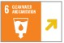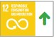

Fiji is ranked the 15th most hazardous country in the world by the World Risk Index, based on high exposure to natural hazards and relatively low coping capacity.

The hazards impacting Fiji most severely are tropical cyclones and floods. Climate change is likely to exacerbate all weather- related hazards in Fiji, and flood severity has already found to be increasing.

Data from INFORM helps assess the risks for climate-related hazards across three dimensions (climate-driven hazards and exposure; vulnerability; and lack of coping capacity).
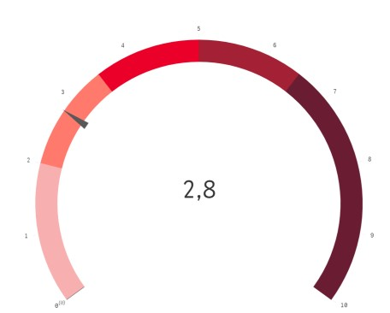

The composite indicator for Fiji is 2.8. Natural Hazard Exposure is rated at 3.9, with several factors weighed against their likelihood and
impact. Lack of coping capacity risks stand at 2.4 (institutional) and 3.4 (infrastructure).

Fiji’s biodiversity plays a key role in protecting the country from natural hazards and faces serious risks due to climate-induced disasters. Fiji’s ecosystems, particularly mangroves, protect coastal communities from erosion and storm damage while providing feeding grounds for fish and invertebrates that Fijians rely on for income and food security. Along with coral reefs, mangroves can reduce wave heights by 84% and decrease storm wave power by 97%. Moreover, Fiji’s ecosystems are key to industry; they are essential for forestry, fisheries,
agriculture, and tourism.²⁸

The destruction of native forests, mangroves, and coral reefs in Fiji contribute to an increase of extreme flooding and sea level rise. The CVA estimates that 40% of native forests are degraded because of clearance for agriculture, illegal logging, gathering of firewood, and growth of invasive tree species. Mangroves are also at risk, declining in area by 25% between 2003 and 2013. Freshwater ecosystems are also at risk in Fiji due to burning and mining, logging, weirs or hydropower dams, catchment alteration, and pollution from urban areas.

Fiji has taken action to protect its biodiversity in recent times, primarily via the National Biodiversity Strategy and Action Plan whose goal by 2050 is to ensure “biodiversity is valued,
conserved, restored and wisely used.”

Between 1970 and 2016, the Climate
Vulnerability Index estimates that over 3.3
million people in Fiji were directly affected by climate-related disasters, with 480 people killed. Urbanization and a lack of climateresilient infrastructure exacerbates Fiji’s vulnerability to climate-related disasters. 90% of Fiji’s population resides in coastal areas, where they are exposed to the impacts of climate change, in housing that is often not climate resilient
Climate-related disasters push an average of 25,000 Fijians into poverty each year and nearly 5,800 people are expected to be displaced per year. Tropical cyclones and floods cause annually estimated average direct financial losses equivalent to 5.8% of GDP. Estimates however differ: IMF research, using EM-DAT data, suggests that Fiji has a 70.3% likelihood of experiencing a disaster each year, causing mean damage worth 1.8% of GDP.
In terms of disaster response, women, older persons, youths, persons with disabilities, identified vulnerable and marginalised groups are more likely to be left behind and require dedicated efforts to ensure their inclusion in decision-making and resilience strengthening measures in line with the Sendai Framework for Disaster Risk Reduction.
Risk protection schemes will help address the immediate post-disaster liquidity needs of affected Fijian populations by building financial resilience of low-income households towards natural hazards and assisting them through market-based climate disaster risk insurance solutions to recover faster.
The National Disaster Management Office (NDMO) under the National Disaster Management Act, 1998 is mandated to coordinate all phases of disaster management in Fiji. Fiji´s National Disaster Risk Reduction Policy (NDRRP) 2018 - 2030 commits to mainstreaming DRR into all its policies, plans and practices and is aligned with the Sendai Framework for Disaster Risk Reduction 2015-2030.
In 2021 Fiji approved its most ambitious piece of legislation on climate to date, which sets the legal framework to enable the country's mitigation, adaptation and disaster risk management actions and summarizes its climate commitments.
Three specific targets have taken Fiji´s climate ambition further: the long-term emissions reduction target for Fiji is net zero greenhouse gas emissions by 2050 (base year: 2021). Fiji’s long term ocean sustainability target for 2050, which is for Fiji’s internal waters, archipelagic waters, territorial seas, contiguous zone and exclusive economic zone to be 100 percent sustainably and effectively managed (base year 2021). And Marine Protected Area target, which is for 30% of Fiji’s internal waters, archipelagic waters, territorial seas, contiguous zone and exclusive economic zone to be designated as a marine protected area by 2030 (base year 2021).

parametric microinsurance product, it will be rolled out through a ‘pilot, test and scale’ approach in partnership with local private sector insurance providers and WFP and will integrate a robust digital onboarding interface to enable last mile reach. The insurance will initially cover smallholder farmers, fishers and market vendors and then expand.

PEACE
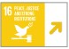
Support to the capacity of security sectors is crucial for Fiji to ensure professionalism and fulfilling their mission with the support of the community. The new draft Police Bill attempts to mitigate against risks and promote accountability.
The Judicial power should continue to be empowered as a key pillar for rule of law. Efforts should be made to support the right of detainees preventing them from the long delayed of the court procedures and remaining unsentenced for long periods of time. Efforts should be made to empower various human rights institutions to become better equipped and capacitated to deal with human rights issues.
Effort should be made to include key groups, including children and youth, women and girls, women survivors of violence, persons with disabilities, persons living in urban, rural, and maritime settlements, older persons, single mothers, LGBTQI+ persons, sex workers, persons living in poverty, populace with limited access to technology and informal workers.
Workers are at great risk of informality, given the reduced size of the formal economy and weak social protection. Almost all women in Fiji are disadvantaged relative to men in the same socioeconomic group. Violence against women has become one of the gravest risks faced by Fijians nowa- days
Politics and governance in Fiji are influenced by challenges inclusion and disparity that derives from the contemporary issues of social cohesion and legacy of the past. They shape social political relationship and translated into land tenure and property issues and the access to social service and political space. Fiji is making a significant progress of democratic elections which is the main pillar of political stability and legitimacy. Fiji will still need to continue on building trust across political actors and space, including between policy makers and civil society groups, the media, professional association and community-based organizations. A stronger
capacity of key institutions including the Parliament and Judiciary are needed for check and balance. Sufficient public consultation and consensus-building will improve the legislative and governance process.
Fiji has ratified all core human rights treaties and is the only PIC to have ratified the Convention on the Protection of the Rights of
All Migrant Workers and Members of their Families. Fiji has also abolished the death penalty in all remnants of legislation where capital punishment was still contemplated. Fiji to further consider ratifying the optional protocols such as the Second Optional Protocol to the International Covenant on Civil and Political Rights; the Optional Protocol to the Convention on the Elimination of Discrimination against Women.
Women and youth to be included in national decision-making processes to allow for a people centered approach toward elimination of genderbased violence and domestic violence, participating in the general elections and advocating on women and youth issues during campaigning stages. Empowering women and youth to stand for the general elections is required.
Fiji is preparing for the general elections. The last day for the announcement of the writ is 26 November 2022 while the last day of elections is 9 January 2023. It is important to have inclusive participation in the general elections especially people living in vulnerable and marginalized situation such as women, youth, people living with disability and LGBTI+ community, persons living in rural, and maritime settlements and older persons.

PARTNERSHIPS
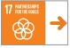

Overall, Fiji enjoys a robust and open relationship with major development partners operating in the region at bilateral, multilateral and also at regional and subregional levels. The overall published ODA stood at US$186.32million dollars (2019) which represented 3% of GDP in 2019. Compared to a year prior, the total aid has declined by 11% (US$211million in 2018). These were pre-COVID levels and aid is expected to increase significantly in 2020, resulting from a steep increase in concessional financing support from key multilateral partners as a result of the dual global crisis of COVID-19 pandemic and the fallout of the Ukraine war which is impacting both donor and developing countries severely.

Aid Statistics by Key Donors and Sectors
Over the period 2019-2020, Australia, Japan, New
Zealand and EU continued to be major development partners for Fiji. The figure below (OECD DAC) provides an average gross ODA by top 10 donors for Fiji. Further below, the second graph represents aid by key sectors against the 2019 aid figures (Pacific Aid Map, Lowy Institute). The funding for Government expenditures, multi/cross cutting, education, transportation and water & sanitation were noted as the top priority sectors for 2019.

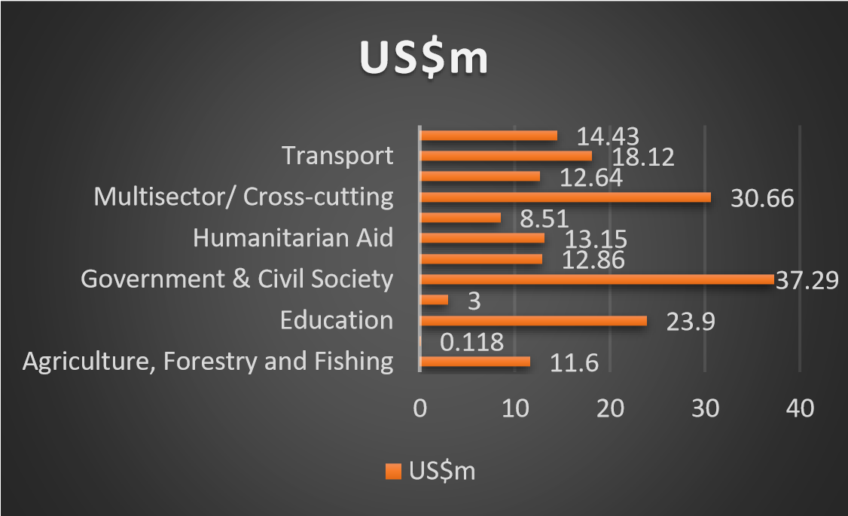

Source: developed with data from Pacific Aid
Map, Lowy Institute

Concessional financing
Highly concessional foreign loans from multilateral development banks and bilateral partners form a significant portion of international financial flows for Fiji. Though the Fijian Government’s practice is to exercise prudence by borrowing at the most concessional rates and given the consecutive and significant economic contractions, debt projections amounted to 89.4% of the GDP (F$9.1billion) by July 2022. Of this, 63% is from domestic borrowings and 37% from external sources. The following table represents the Fijian Government’s debt positioning from financial year 2017-2018 to 2021-2022 period.

TUVALU

Key CCA takeaways
An upper-middle income country with GDP per capita estimated at US$5,292 in 2021, Tuvalu has experienced solid growth over the two last decades, prior to COVID. Tuvalu has also attained universal literacy, universal access to electricity, good internet and mobile penetration, and declining neonatal and under-5 mortality rates. Public expenditure on health and education remains high.
Despite these achievements, Tuvalu’s first VNR in 2022 notes that the overall progress towards the
SDGs have been mixed, with clear signs of progress in some sectors, yet ongoing challenges in others. Among the challenges, Tuvalu continues to have a high poverty rate. It is one of the few Pacific countries where absolute poverty still exists. High levels of inequality have also been observed as a concerning, widening trend. The country has a very limited social protection system. And women and girls are relegated in all spheres of social life, especially in employment, education, public office, representation and decision-making positions.
Furthermore, Tuvalu still suffers from low access to safely managed drinking water, high prevalence of anemia, lack of Sexual and Reproductive Health services especially for its adolescent population, poor sanitation and low water storage capacity, and the presence of HIV, STIs, TB, substance, alcohol and tobacco abuse, and NCDs.
Throughout the pandemic, Tuvalu was largely assisted by COVID-19 fiscal response, support from development partners, and stable fisheries revenue. The continuing rising international commodity prices are a concern for this import capita between $1,086 and $4,255; upper middle-income economies are those with a GNI per capita between $4,256 and $13,205; high-income economies are those with a GNI per capita of $13,205 or more dependent country as it erodes real household incomes. The July 2021 IMF-World Bank LIC DSA assessed Tuvalu as at high risk of debt distress but public debt is deemed sustainable.
While the direct impacts of the Russian invasion of Ukraine is observed to be relatively small due to limited economic linkages with both countries and the wider European region, the Pacific including Tuvalu is experiencing indirect impacts from the war—through commodity prices, global growth prospects affecting major economic partners, and exchange rate movements. Since fuel constitutes 20% of Tuvalu’s total imports, international fuel price shocks generally translate into compounding impacts across most commodities.
Going forward, Tuvalu must continue investments in connectivity, air and sea transportation (new airline and modern airport, revamped port infrastructure) and service substitution, such as with the expatriation of medical referrals (TMTS) and overseas scholarships.
Tuvalu ought to invest in its youth, in equality and in the development of a small but highly performing private sector. It has a youth bulge and a demographic dividend to seize (provided that it is able to address the high levels of adolescent pregnancy). It must abide by its international human rights obligations and make equality between men and women a reality, eradicating VAWG, maintaining educational opportunities for girls (and for boys) all the way through the acquisition of skills that are valued by the labour market, and introducing measures to boost equality of opportunity in the workplace.
Tuvalu may wish to analyze what it would take for interested candidates to participate in labour mobility schemes with regional neighbors, and for these to widen Tuvalu´s quotas. Such a participation would increase skills, remittances and employment options, while watching brain drain as a collateral risk.
Like other PICTs, diversifying the economy is a protection against shocks. Relying on fishing licenses and ODA as sources of income is risky and may face the volatility of both revenues if other nations decide to reduce their support, their activity or valued fish species migrate. Developing a quality ‘adventure tourism’ offer, based on attractions that Tuvalu can develop; intensifying small-scale agriculture to reduce overreliance on imported foodstuffs; and inserting itself in the global economy through digitalization and fintech are options the Government may wish to analyze further. Import substitution through improved livestock and animal feed management and production would increase food security and nutrition levels on-island, while reducing food imports dependency and trade deficits.
Furthermore, the design of a new, diversified, Blue Economy could attract FDI, generate growth by a newly developed private sector and create the jobs the Tuvaluan youth and women need to participate meaningfully in society.

PEOPLE
Vulnerability in Tuvalu is intersectional and compounded by overlapping identity factors such as age, gender, ethnicity, disability, sexual orientation and gender identity, geographic location, and socio-economic status. Among the most vulnerable in Tuvalu are women and girls, particularly women survivors of violence, girls and adolescent girls, persons living in poverty, persons with disabilities, and dwellers of the outer islands.
On SDG 1, poverty in Tuvalu has been increasing and there are still people living in absolute poverty, a situation seldom seen in the Pacific. According to estimations from SPC, 35% of the total population lived under the national poverty line in 2020, up from 26.3% in 2010 and 16.5% in 2005. The income gap has also widened, with the Gini coefficient increasing from 39.1% in 2010 to 43% in 2015.
Tuvalu has made considerable progress in SDG2 by reducing hunger, improving food security and nutrition. According to the MICS 2019, prevalence of stunting in children under the age of five dropped from 10% in 2007 to 5.7% in 2019; prevalence of wasting dropped from 3.3% in 2007 to 2.8% in 2019. These figures are also significantly lower than the PICTs averages (9.0% wasting, 41.4% stunting, and 8% overweight) and the world averages.
However, despite low rates of malnutrition, micronutrient deficiencies in both women and children are prevalent. Furthermore, according to the 2021 ‘State of Food Security and Nutrition in the World’ report, the prevalence of obesity in the adult population has increased from 48.6% in 2012 to 51.6% in 2020.
There is a shortage of locally produced food in Funafuti. Inter-island transport is erratic and expensive, reducing opportunities to source perishable foods from outer islands and increasing dependence on imported foods. With the COVID19 pandemic further disrupting food supply, a transformation of food systems will be critical to achieving SDG 2 and ensuring food security and nutrition in Tuvalu. This includes traditional foodways and local farming, pastoral, fishing, hunting and food preservation systems that are based on knowledge and practices transmitted from generation to generation and form part of the ancestral knowledge promoted under the 2003 Convention for the Safeguarding of the Intangible Cultural Heritage.
Tuvalu has made progress in improving the health and well-being of children. While the SDG target for neonatal mortality was achieved, the target for under-five mortality has yet to be reached. The latest MICS indicated a reduction in neonatal mortality to 8 per 1,000 live births, while under five mortality was estimated at 30 per 1,000 live births.
Tuvalu’s maternal mortality rate is zero, a figure that needs to be interpreted with caution, given the small number of vital events in Tuvalu. Another issue of concern is the increase of Tuberculosis incidence from 205 per 100,000 in 2016 to 296 per 100,000 population in 2019.
The CEDAW Committee commended Tuvalu for improving access to health care for populations on the outer islands but noted that women continue to
Proposal for the North Pacific Federated States of Micronesia, Kiribati, Republic of the Marshall Islands and Tuvalu.
experience difficulties in gaining access to affordable and adequate health care and that there is a lack of SHR services, including age appropriate school education on SRHR.
Tuvalu has achieved near universal access to improved water services and achieved a comparatively high level of sanitation services access, with 82.3% of the population having access to basic sanitation services, higher than the regional average of around 72%. However, the main challenge for Tuvalu is the access to safely managed water and sanitation services for all Tuvaluans.
In terms of SDG 4, in 2016 government expenditure on education amounted to 20% of its GDP, the highest in the region. However, Tuvalu seems to have regressed in achieving quality education for all. School enrolment rates in ECE, primary education, and secondary education have been declining since 2015, while the number of school drop-outs has been rising. According to data from UNESCO, gross school enrolment in pre-primary education declined from 96.4% in 2015 to 78.9% in 2020; gross school enrolment rate in primary education declined from 99.8% in 2015 to 85.5% in 2020.
Gender equality remains a major challenge in Tuvalu. A 17% gap in the labour force participation exists between women and men. The participation of women in the labour force, either formally or informally, has declined from 51% in 2012 to approximately 40% in 2017. Women are overrepresented in the subsistence economy and underrepresented in the formal employment sector. Women also generally earn less than men and are perceived as care givers and responsible for domestic duties. Equal rights to land ownership is another critical dimension of women’s economic empowerment that is highly restricted in Tuvalu.
Furthermore, there is a stark gender disparity in parliamentary representation and participation in government, including the judiciary and diplomatic service. Although Tuvalu appointed its first female Acting Governor-General in 2019, only one woman was elected in the last polls to parliament, and as of February 2021, this MP represents 6.3% of the Parliament seats.
Women are usually not allowed to attend the decision-making meetings of the Falekaupule (local government). It has been reported that the government has the intention to modify this rule, authorising women to participate on an equal footing.
Gender-based violence is endemic in Tuvalu. According to Tuvalu’s DHS 2007 , 37% of women have experienced physical violence any time since the age of 15, while nearly 25% reported having experienced physical violence in the 12 months preceding the survey.
In the COVID-19 context, the evolution of instances of violence against women and girls is unclear, although police data indicates that the number of times it had to intervene in cases of domestic violence in Funafuti for the period of January to May was higher in 2019 than in 2020. However, more contemporary data and analysis are required to analyse this trend.
Tuvalu has a very limited formal social protection system. The Tuvalu National Pension Fund (TNPF) provides superannuation to nearly 60% of the population. However, there are currently no social assistance programmes targeting children or families in poverty and other vulnerable population groups, such as PWD.

PROSPERITY

In Tuvalu, the gradual easing of restrictions and reopening of borders is expected to accelerate growth to 3.5% in 2023 and 4.0% in 2024. Additional revenue of 2% of GDP is expected from the reinstated tuna transhipment in February 2022 in the capital Funafuti after a two-year COVID-19 ban.
Agriculture remains the mainstay of Tuvalu’s economy with a total value of US$7.5M in 2017, though its contribution to GDP has been in decline. Together, the agriculture, hunting, forestry, and fishing sectors contributed 18.7% of national GDP in 2017, a drop from 26.6% percent in 2010. Domestic agricultural production is largely at a subsistence level. A very high proportion (90%) of the households surveyed in the 2017 census reported some type of agricultural activity, including livestock raising (84% of households), crop growing (69%), buying or selling fish (60%), and handicrafts (35%).
Additionally, Tuvalu is highly dependent on coastal fishery resources to meet domestic needs and safeguard food security. Recent work, using data from the Pacific Forum Fisheries Agency (FFA), suggests that the average annual tuna access fees for Tuvalu for the period 2015-2018 was US$25.6M, equivalent to 56.9% of government revenue. The World Bank estimates that fisheries could generate between US$15-24M per year in additional revenue by 2040 and significantly boost income in Tuvalu, through technology advancements to enhance fishing efficiency, improved product quality and fisheries monitoring and surveillance.
Unlike in other PICTs, tourism plays only a limited role in Tuvalu. In 2018, the international tourist arrivals were estimated to be around 2,700, many of them on business and several others involved in technical assistance and development cooperation. The international tourist receipts represented pre-COVID around 8 % of Tuvalu´s GDP. Several reasons constrain the development of tourism in the country, including scarce air transportation routes, underdeveloped tourism infrastructure, lack of amenities and leading competition by more established destinations in the region.
Long-standing constraints on agricultural production in Tuvalu include a very high vulnerability to climate change impacts, including saltwater intrusion of agricultural lands, pulaka pits, and freshwater lenses; coastal erosion; inundation and flooding of agricultural lands; increased risk of drought; and growing intensity of natural disasters.
Land tenure systems that limit land availability are a risk to agriculture expansion and beyond, to any economic development that would require land, such as tourism. Poor inter-island transport links and declining interest in traditional agricultural practices represent a risk to food security and to the provision of any public or private services. In each of these areas, attention to gender equality will minimise the risk that women will be left still further behind, undermining overall progress.
Tuvalu has a high unemployment rate, particularly for the youth segment. According to Tuvalu’s Population & Housing Mini-Census conducted in
2017, the total national unemployment rate is 28.5%, reduced from 39.6% in 2012. The unemployment rate for females is 30.4%, compared with 27.2% for males. It is worth noting that these figures cover only formal employment, excluding unpaid family workers, paid informal employment, and other remunerated or nonremunerated working occupations. Based on standard definitions used globally, a World Bank estimate places Tuvalu’s overall unemployment rate at 8.5% in 2016, 4.6% for males, 16.2% for females, and 20.6% for youth.
Tuvalu’s EEZ of 751,672 km² is ranked the 38th largest in the world. Tuvalu’s blue economy potential presents valuable opportunities for the country’s economic transformation: on-shore and off-shore fishing, offshore renewable energy, sustainable aquaculture, sustainable aqua tourism, marine biotechnology and ocean monitoring and surveillance, ocean-related tourism and fisheries, which all provide opportunities for economic growth and more diversity in the SIDS’ economies.
Currently, there are no measures in place promoting the Blue Economy. To accelerate the transformation, other SIDS have formulated a comprehensive Blue Economy development strategy, sector specific plans and comprehensive and integrated spatial management instruments. Experts from Tuvalu have already suggested a way forward for the development of a National Oceans Policy, which coincides significantly with the concept of Blue Economy discussed in this Assessment.
Harnessing Tuvalu’s demographic dividend is key to the country’s economic and social transformation and attainment of the SDGs. Tuvalu will have in the next two decades an increasing share of young generations in its population, who are today´s growing cohorts in the education system, soon knocking at the doors of the labour market. Tuvalu has a young population. According to the 2017 census, Tuvalu’s median age is 25.1 years. 32% of Tuvaluans are under the age of 15 years, while 58.5% are at the working age between 15 and 59 years. Only 9.5% percent is above the age of 59 years.
This will open a window of opportunity for economic growth as the population structure gradually matures and a larger share of the population enters the workforce. The demographic dividend can be reaped through sound policies, which ensure that as large waves of young people enter the labour market, they bring with them relevant skills, are adequately educated and jobs exist for them. Education, training and a well functioning labour market are prerequisites to reap the demographic dividend.
Tuvalu has made progress in ensuring access to affordable, reliable, sustainable and modern energy for all. By 2017, Tuvalu had achieved universal access to electricity, from 94.6% in 2002. At the same time, it had increased the usage of clean fuels and technologies. According to the MICS 2019-20, 89.7% of the population are primarily reliant on clean fuels and technologies for cooking, nearly 41% more than the 48.5% in 2015. Due to the introduction of clean fuels and technologies, the share of renewable energy in the total final energy consumption increased to 13.5 % in 2017 from 0% in 2011.
Tuvalu’s Government has planned to increase the share of electricity from renewable energy sources to 100% and increase energy efficiency by 30%. It has communicated its intention to reduce the emissions of GHG from electricity generation by 100% by 2025 and to reduce the total the emissions of GHG from the entire energy sector to 60% below 2010 levels by 2025.
Access to telecommunications and Internet in Tuvalu has increased considerably the nation´s connection with the rest of the world in terms of Internet usage and telephone coverage. Both Internet penetration and telephone penetration are above regional figures. According to the latest Multiple Indicator Cluster Survey (MICS), 62.6% of urban households have access to Internet at home. In rural areas, only 31.4% of homes had Internet access. Digitalization, e-commerce, eGovernment services and the use of the electronic marketplace provide businesses, especially SMEs, with opportunities for reaching customers in distant markets, and opens the door for entrepreneurship, innovation and remote servicing of citizens living on the outer islands. The COVID pandemic has highlighted the value of contactless education, health, commerce, and other interactions.
Te Kete has identified harnessing the digital transformation to improve lives as a national development priority and aims to digitalize Government services to perform them online. Accelerating Tuvalu’s digital transformation depends on improving the enabling environment for the development of a digital economy, including transportation, logistic, access to finance or trade facilitation. Therefore, Tuvalu needs to expand its Information and Communication Technology (ICT) capabilities.
Key policy recommendations for Tuvalu in the Staff Report on the 2021 Article IV Consultation with the IMF include:
- Implementing reforms to (i) achieve gradual fiscal consolidation (ii) fund climate adaptation and infrastructure maintenance needs.
- Developing effective prudential regulation and supervision of the financial system
- Continuing implementation of structural reforms to encourage diversification away from the public sector and improve access to credit.
- Strengthening the institutional capacity of domestic institutions to produce high quality statistics to improve the policy making process.

PLANET

INFORM ranks Tuvalu 104th out of 191 countries on exposure to natural hazards.²⁰ Tuvalu is one of the nations of the world whose land could physically disappear, submerged by the sea level rise provoked by climate change. It is thus highly exposed and vulnerable to extreme weather and climate-related events, including cyclones, sea level rise (SLR), coastal flooding, drought, extreme heat, and tsunamis.
Coastal erosion and the destruction of reefs are also negatively impacting infrastructure, fisheries, and the agriculture sectors as well as the natural biodiversity of the ecological systems. Further impacts on human health are also expected. An UNDRR study based on EM-DAT data estimates that Tuvalu has a 16.2% chance of suffering a disaster related to natural hazards each year, affecting an average 42.6% of the population.
Development gains in Tuvalu can and have been easily wiped out by disasters. During Cyclone Pam in March 2015, storm waves displaced 45% of the people and inflicted economic loss and damage estimated at $US10.34M, over a third of the country’s GDP at the time.
According to recent IPCC projections, Tuvalu is expected to experience a number of changes to current climatic conditions that will likely have far reaching consequences. Some expected changes are:
- Increasing temperature: temperature has increased at a rate of 0.10°C per decade since 1933 and will continue to increase.
- Ocean acidification: increased ocean acidification impacts food security (threat to the diversity and abundance of reef fish and permanent alteration of the fishing industry with migratory fisheries stocks predicted to move eastwards and into adjacent high seas).
- Sea-level rise: the trend for Tuvalu is 4.7mm per year (increased by approximately 13.2cm 1993 – 2021).
- Increased frequency and intensity of climate hazards
Together with Kiribati, Maldives, the Republic of Marshall Islands and Tokelau, Tuvalu is part of the Coalition of Low-Lying Atoll Nations on Climate Change (CANCC), which describes itself as an Early Warning System for the global community.
Pacific leaders have thus acknowledged climate change as the single greatest threat to security in the region in the 2018 Boe Declaration (Nauru) and included climate security as the strategic focus area in its implementation plan. The Tuvalu National Climate Change Policy (2012) (NCCP) establishes the framework of action to reduce the impacts of climate change.
Additionally, internal migration and outmigration have been a common trend in Tuvalu with livelihood safety and security threats by climate change and environmental hazards as major deciding factors. In-depth assessments of climate change exposure, vulnerability, and the potential for displacement of resident populations around the islands is urgently needed.

In terms of major threats to biodiversity in Tuvalu, they include SLR, rising population density in Funafuti, decline in traditional resource management, unsustainable use of natural resources, poor waste management and pollution control, and invasive species.
Tuvalu has an ongoing commitment to ratifying the 1972 Convention Concerning the Protection of the World Cultural and Natural Heritage (World Heritage Convention), as indicated in the Tuvalu National Culture Policy Strategic Plan (2018-2024) where Objective 2: ‘Protect and preserve the Tangible Cultural Heritage’ includes the need to “Launch a national process with a view to joining the UNESCO 1972 World Heritage Convention as a major priority through awareness raising activities and consultations in the islands”. The limited human and financial resources available have hindered the efforts thus far. Tuvalu is one of few UNESCO Member States that has not yet ratified the World Heritage Convention.
Technical capacity is the greatest DRR strategies and climate policy implementation challenge for Tuvalu. For example, each island has an Island Disaster Committee (IDC) whose main function is to coordinate disaster-related measures between the National Disaster Committee and the local community. More capacity building initiatives are needed to support the IDCs so they can accomplish their role.
Consistent power supply, reliable Internet connections and robust early warning and communication equipment, capacity development along with national agencies and community SOPs are critical for strengthening Tuvalu’s tsunami warning and mitigation system. These priorities are aligned with the Intergovernmental Oceanographic Commission (IOC) Decision A-31/3.4.1- specifically the Ocean Decade Tsunami Programme endorsed at the IOC 31st Assembly in June 2021.
Tuvalu signed and ratified the Paris Agreement in April 2016. Tuvalu’s Second National Communication was submitted to the UNFCCC Secretariat in December 2015 and its Intended Nationally Determined Contribution (iNDC) was communicated to the Secretariat in November 2015. Within its iNDC, Tuvalu commits to reduce emissions of green-house gases (GHG) from the electricity generation power sector by 100%, i.e., zero emissions, by 2025. Tuvalu’s indicative quantified economy-wide target for a reduction in total emissions of GHG from the entire energy sector is of 60% below 2010 levels by 2025. These emissions will be further reduced from the other key sectors including agriculture and waste, conditional upon the necessary technology and finance transfers. Tuvalu’s iNDC, focussed primarily on mitigation and adaptation, will be articulated through its National Adaptation Programme of Action (NAPA), National
Communications, National Strategic Action Plan for Climate Change and Disaster Risk Management, and National Climate Change Policy.

PEACE
Tuvalu has acceded to three of the core Human Rights treaties as expression of the country´s commitments under international human rights norms and standards, and engagement with international HR treaties and processes. Tuvalu’s next Universal Periodic Review is scheduled for
May 2023. The Government´s limited administrative capacity creates particular constraints with regard to reporting requirements under UN instruments and reluctance to further adhere to other treaties. Tuvalu has extended a standing invitation to the Special Procedures of the UN Human Rights Council. A visit of the Special Rapporteur on Cultural Rights was paid to Tuvalu in 2019.
Women’s limited access to justice, particularly on the outer islands, continues to be a critical issue. The Office of the People’s Lawyer is the main agency providing legal aid and free legal advice for people who are at a financial disadvantage or who are unable to access private legal representation, but it reportedly lacks financial and human resources to reach out to the needy. It also lacks a comprehensive and effective system for receiving complaints.
Some of the notable risks to social progress and social cohesion are on women’s empowerment. While the law provides equal opportunities for men and women, in reality women have to overcome almost insurmountable barriers to participate in public life and access leadership positions. The law is not gender-sensitive, representing an additional risk of discrimination. The labour force participation rate is almost 20% higher for men than for women. Women are more often unemployed than men. But girls have better school attendance than boys between 14 and 18 years of age. Education outcomes are therefore not the cause of labour market inequalities.
The absence of a comprehensive social protection system that effectively targets those who are most in need is a significant gap and risk, particularly in the context of diminishing traditional support systems and the volatility of remittances, highlighted during the COVID-19 pandemic. There is a risk of Tuvaluans not being able to participate further in labour mobility schemes, with consequences in terms of remittances, vulnerability of relatives’ households, skills development of migrants and economic dynamism of Tuvalu.

The constitutional monarchic nature of the country’s governance has been subject to two constitutional referenda, in 1986 and 2008; each time, the change to a Republic has been rejected by voters. A third constitutional amendment process has been ongoing during the past three years, involving a large citizens’ consultation throughout the country. Among other aspects, the proposed amendments include the direct election of the PM, changes to the Bill of Rights, and the rule that no more than one-third of the Members of Parliament could be members of the Government. Wary that the process could fail like previous attempts, a Parliamentary Select Committee currently holds further consultations with various stakeholders, including youths, communities and Civil Society Organisations (CSOs). Direct election of the PM might partially mitigate Cabinet instability and reduce the frequency of votes of no-confidence, which have been a common occurrence since independence.
While the laws provide equal opportunities for men and women, women need to overcome very serious cultural barriers when contesting elections. Such barriers include the traditional and stereotypical perceptions of women’s roles as homemakers, caregivers and nurturers of the family; financial constraints linked to the cost of running a campaign; and the nature of voting, which tends to be connected to relational and family lines rather than based on the merits of candidates. The situation is exacerbated by the absence of political parties, which could be a tool for affirmative action by allocating safe seats to women.
Prominent civil society organisations include Tuvalu’s Association of NGOs (TANGO), the Tuvalu National Council of Women and the Tuvalu National Youth Council. TANGO, the official umbrella organisation for NGOs in the country, is encouraging and assisting NGOs in their developmental work mainly through capacity building and networking. The Tuvalu National Council of Women is focused on women´s empowerment. The Tuvalu National Youth Council is encouraging developmental youth projects and engages with Government and donors so that they provide resources for the sector. An environmental NGO, Alofa Tuvalu, was formed in 2005 to devise coping and mitigating mechanisms to the climate change threat. The NGO has several hundreds of members and receives support from the Government.

PARTNERSHIPS

Tuvalu continues to benefit from multilateral partnerships with International Financial Institutions (IFIs) such as the World Bank and Asian Development Bank (ADB) providing concessional financial support in key sectors. Since 1993 ADB has been supporting Tuvalu and has committed 43 public sector loans, grants, and technical assistance totalling $102 million to Tuvalu. Cumulative loan and grant disbursements to Tuvalu amount to $41.2 million. ADB’s ongoing sovereign portfolio in Tuvalu includes 11 grants worth $65.7 million. ADB priorities in Tuvalu include improving maritime facilities, strengthening disaster resilience, advancing renewable energy, upgrading water and sanitation, promoting health and COVID-19 preparedness, and enhancing prudent fiscal management.
In terms of financing from the World Bank, its reported that since Tuvalu become a member in 2010, it has delivered approximately US$140.8 million across 13 projects to date, with 7 active projects in the portfolio. In September 2021, the World Bank and Tuvalu signed a new Establishment Agreement which opened the door for additional technical support and expertise in a range of areas critical to development and resilience. Through IFC, the World Bank is expected to support Tuvalu to foster conditions that are more favorable for private sector investments.
The graph below provides a quick trend on total financing inflows and outflows for Tuvalu generally over a 10-year period. Data below (figure below extracted from UNCTAD³³) indicates that Tuvalu has experienced quite weak foreign direct investments over the years, and this is an area being currently supported by partners such as World Bank as indicated above to improve foreign investments potential and interest. Personal remittances continued to show a deteriorating trend over the 10-year period, for instance from as high of $6.5million in 2002 to $0.9million in 2019³⁴.

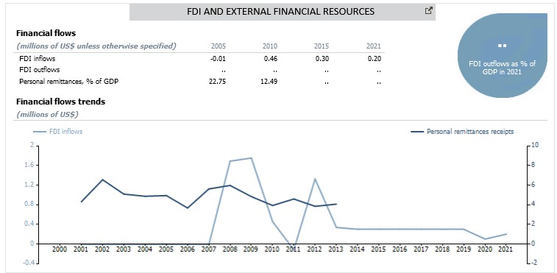

Overseas Development Assistance Overall, the ODA trend for Tuvalu presents a positive outlook over the last 3-4 years, with 2020 showing an overall ODA of USD$43.32 million. ODA for Tuvalu represents an improving trend over the past 2-3 years (2018-2020), representing a significant 78% or more of the GDP (2020). Tuvalu is currently one of highest recipient countries of ODA, second to Nauru in the Pacific region, with a per capita ODA noted at US$3,130 against a Pacific regional average of US$424 per capita³⁵.

34 https://data.worldbank.org/indicator/BX.TRF.PWKR.CD.DT? locations=TV
35 https://data.worldbank.org/indicator/DT.ODA.ODAT.PC.ZS?
locations=S2

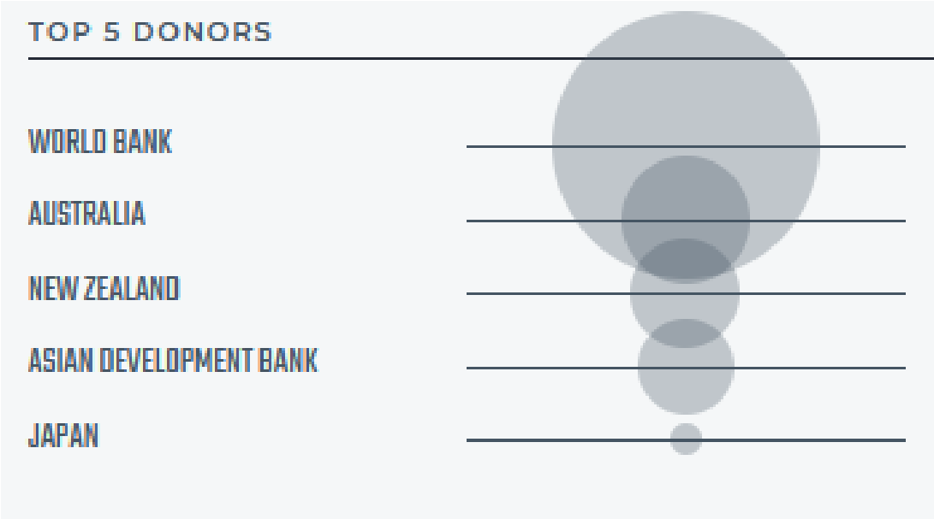
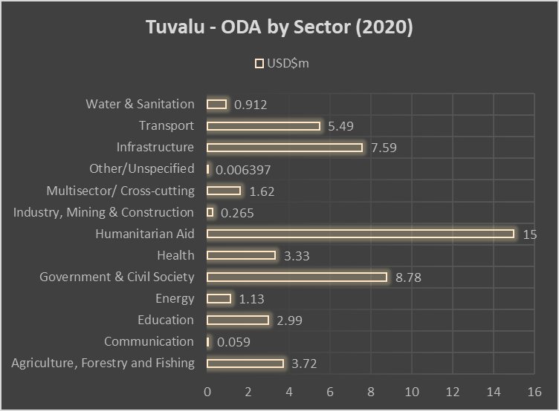
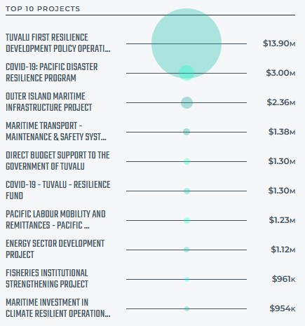
Tuvalu Country Data, Lowy Institute – Pacific Aid

Pacific Aid Map for
T
uvalu

-

20
20
, Lowy Institute

The World Bank was the largest contributor of
ODA for Tuvalu in 2020.
The other top ODA
contributors (both ODA grants and loan) are
Australia, New Zealand, ADB and Japan
.
The
tables below provide data on key sectoral financing
from international sources fo
r
Tuvalu

in 20
20
.
Further below, it can be noted that some of the key
sectoral aid is received in the areas of
Humanitarian
aid; Government & Civil Society; Infrastructure;
Transport; Agriculture, Forestry and Fishing and
Health sector
.

Above Chart developed through ODA mapping
by Lowy Institute for
Tuvalu

(2019)

Map (2020)

Vanuatu
Key CCA takeaways
Vanuatu graduated from the Least Developed Country (LDC) status in December 2020, at a time when it was suffering from the dual impacts of Category 5 Tropical Cyclone (TC) Harold and COVID-19 lockdowns. Its LDC Smooth Transition Strategy is premised on the National Sustainable Development Plan (NSDP), as its goals and policy objectives are interlinked with the LDC support measures, including poverty reduction, broadening the economic base, building capacity, institutional strengthening, and boosting international trade.
Vanuatu has been granted an extension of international support measures related to aid for trade and participation in international forums, until 4 December 2025. Vanuatu reopened its borders in July 2022 with flights from Australia and New Zealand.
While the direct impacts of the ongoing Russian invasion of Ukraine is observed to be relatively small due to limited economic linkages with both countries and the wider European region, the Pacific including Vanuatu is experiencing indirect impacts from the war—through commodity prices, global growth prospects affecting major economic partners, and exchange rate movements. Bus drivers in Vanuatu have requested the government to increase fares, and bus fares in Fiji were raised by more than a third partly to cushion the impact of rising fuel prices (Pratap 2022).

After contracting by 5% in 2020, Vanuatu’s economy grew by 1% in 2021 and is expected to grow by 2% and 4% respectively in 2022, and 2023. Challenges continue to be significant including distance from major markets, climate change, disaster vulnerability and limited options for economic diversification. Compared to other Small Island Developing States (SIDS) in the region, Vanuatu’s GDP per capita remains low at $3,127 USD (2021)
Revenues from the Honorary Citizenship Programs (HCPs), which provide passports in exchange for investment, have helped shore up the fiscal balance, though their long-term contribution is uncertain. The government has used windfall HCPs revenue, which has exceeded budget estimates, to build cash reserves, finance spending on disasters, and pay down debt. After rising by an average of 47.5% yearly from 2017 to 2020, HCPs revenue dropped by 10.5% in 2021.
In May 2022, the Government of Vanuatu declared a climate emergency, highlighting the country’s vulnerability to extreme weather events. Vanuatu is taking steps to reduce the adverse impact of climate change and disasters caused by natural hazards on its economy, including by investing in climate resilient infrastructure. The large cost associated with adaptation, mitigation, and damages from disasters means that accessing concessional resources, and mobilizing domestic revenue, will be crucial to meet the rising development spending needs. Equally important will be the ongoing efforts to improve public investment management and build fiscal reserves to buffer against climate induced shocks.
Adding together the cumulative cost of adaptation, mitigation and recovery for damages and losses from disasters, the government estimates that the “real cost” of achieving Vanuatu’s NDC under the Paris Agreement will reach $1.2 billion by 2030. Although expected to be spread over several years, this cost is about 120% of 2021 GDP. Around 60% of the cost is for adaptation, 26% for mitigation, and the remainder for recovery of losses and damages (Government of Vanuatu 2022).
Vanuatu’s disaster risk is the highest in the world, according to the World Risk Report 2021. Aside from cyclones, Vanuatu is at risk of volcanic eruptions, earthquakes, tsunamis, and climate induced events, such as sea-level rise. In the past, disasters have had an outsized impact on Vanuatu’s economy. Damage caused by Cyclone Harold, which struck in 2020, was estimated to be equivalent to more than 50% of GDP (Government of Vanuatu 2020).
The frequency and severity of disasters also affect Vanuatu’s fiscal and debt sustainability (World Bank 2021). Damage to properties and livelihoods erode the economic base for revenue collection. Meanwhile, reconstruction and upgrading of infrastructure adds to expenditure, and can increase borrowing. For example, disbursements for reconstruction and upgrading of infrastructure following Cyclone Pam in 2015, contributed to an increase in public debt from the equivalent of 23% of GDP in 2014 to 45% in 2017 (ADB 2018).
The multiple risks that Vanuatu faces do not exist in isolation from one another, and in many instances are interconnected and systemic, with compound and cascading impacts. It is therefore critical to support the government to take a cross sectoral approach to risk management.
The profile of risks due to climate change and geohazards has identified a reduced availability of fresh water, more pests and diseases of animals, crops and trees, saltwater inundation and intrusion of coastal land and groundwater, coral reef deterioration, reduced fisheries productivity, increased risk of human disease and health problems, including vector-borne and zoonotic disease transmission and heat-related illnesses, damage to infrastructure, loss of coastal land and reduced economic growth and revenue generation.
Analysts consider that Vanuatu has largely been spared the civil and political unrest of neighbouring Melanesian nations and consistently ranks as one of the happiest nations in the world, but its economy is failing to meet the needs of an increasing and young population. Employment choices for youth remain very limited, while adolescent pregnancy is very high, both poisoning the well of the demographic dividend with the increased cohorts of NEET. Informality has become a risk for the labour market, given its spread. Vanuatu is at risk of missing the boat of digital transformation and with it, the best opportunity for its economic diversification.
Financial exclusion is a reality in Vanuatu.
Gender equality remains a major challenge in Vanuatu. Discriminatory gender stereotypes and patriarchal attitudes persist regarding the roles and responsibilities of women and men in society and in the family. Patriarchal norms and traditional cultural practices reinforce women’s subordinate position in society. Women and girls in Vanuatu also suffer exclusion in many aspects of public life, particularly in education.
Social risks point at the endemic level of GBV and VAWG and widespread community tolerance of both. The nation’s health and education infrastructure are not fit for purpose. There is a severe lack of access to adequate family planning, a problem most acutely experienced by girls and women, although it impacts the entire economy.
Vanuatu has acceded to five of the core Human Rights treaties as expression of the country´s commitments under international human rights norms and standards, and engagement with international HR treaties and processes but is encouraged to ratify the International Covenant on Economic, Social and Cultural Rights, the International Convention on the Elimination of All Forms of Racial Discrimination and the International Convention on the Protection of the Rights of All Migrant Workers and Members of Their Families.
There is a strong need to balance the interface between formal and traditional governance systems. The country’s formal social protection system needs strengthening, as assessed by ADB’s Social Protection Indicator. The majority of social protection monies are spent on social insurance contributory schemes. Social assistance measures are much more limited.

PEOPLE
Vulnerability in Vanuatu is intersectional and compounded by overlapping identity factors such as age, gender, ethnicity, disability, sexual orientation and gender identity, geographic location, and socio-economic status. The most at risk and vulnerable include women and girls, women survivors of violence, children, young women and boys, people with disabilities, inhabitants of the outer islands, and families living in poverty or hardship.
In all left behind groups, women are likely to be left furthest behind. The inhabitants of outer islands and informal urban settlements face a greater hardship and difficulties in accessing public services than the other Ni-Vanuatu. The highest rates of hardship are found in the rural provinces of Tafea and Torba.
On SDG 1, poverty rates in Vanuatu remain relatively high. The poverty headcount rate was estimated to be 13.2% percent in 2010, based on the international poverty line of $1.90. Using the latest national measures, 15.9% of the approximately 47,000 lived below the basic-needs poverty line in 2019/2020 as per the international poverty line for Lower Middle-Income Countries (LMIC) (US$3.20 per day per capita) rising to 19% in urban areas. Assessed in terms of vulnerability to external shocks, an estimated 36 % of households are at risk of falling into poverty.
Vanuatu has contributed to the discussion on contextualising poverty in-country. ⁸ Poverty is equated to hardship in Vanuatu´s social and economic analyses and policy statements. Recognising that hardship exists in Vanuatu, a different perspective is offered than what is considered poverty in other countries. 80% of the population depends mainly on the land for food and lives significantly outside the cash economy. In that context, many Ni-Vanuatu are facing hardships in terms of what they have and what they lack. Hardship takes different forms, but much of it is lack of access to education, land, transportation, communications, energy and sanitation. These impediments are some of the measurements the NSDP has attempted to produce. The rate of hardship for Vanuatu, defined as those individuals living below the “National Poverty Line” (NPL), is estimated to be 15.9%, with 96.7% of people in hardship living in rural areas.
Compared to other East Asia and Pacific countries, inequality in Vanuatu is relatively low with the Gini index estimated at 32.3 in 2019-20 based on per capita consumption. In absolute terms, people in hardship number the greatest in Tafea (14,066), Malampa (9,069), rural Sanma (8,706) and Penama (5,204).
Vanuatu’s progress on SDG 2 continues to be a major challenge with signs of deterioration. The country experiences change points in correspondence with climate change and economic downturn. The proportion of the population suffering from hunger is on an incline, with 9.8% of the population suffering from undernourishment in 2018/20.
In terms of SDG 3, Vanuatu has made progress in past decades to improve health and well-being for its population but has not yet achieved the Sustainable Development Goal (SDG) targets for child mortality. The neonatal mortality is estimated at 11.4 per 1,000 live births while under-five mortality is estimated at 29 per 1,000 live births.
Vanuatu needs considerable investment in improving both availability and access to sexual and reproductive health services. Antenatal coverage to pregnant women who received an average of 4 antenatal clinic visits, has remained stagnant at 52% between 2013 and 2018.
Within the adult population, 35.8% of men and 49.5% of women aged 15 to 49 are overweight. However relative to other PICTs, Vanuatu has the lowest rates of overweight, obesity and premature death.
The government of Vanuatu assesses that the country is making a steady progress on SDG 4. Education access is monitored on attendance and education retention rates from kindergarten through years 6 and 13. The year 6 survival rate of 64% in 2017 is on the way to meeting the NSDP target of 85%. The 11.4% survival rate for year 13 is below the target of 30%.
In terms of SDG 5, gender equality remains a major challenge in Vanuatu. Discriminatory gender stereotypes and patriarchal attitudes persist regarding the roles and responsibilities of women and men in society and in the family.
Women also face high rates of violence by husbands or partners. Among women who have ever been married, lived with a man, or had an intimate sexual relationship with a partner, aged 15-49, 3 in 5 (60%) experienced physical and/or sexual violence in their lifetime.
Women and girls in Vanuatu also suffer exclusion in many aspects of public life, particularly in education. Although there has been progress achieved in increasing the enrolment and completion rates of girls at the primary level, dropout rates among girls at the secondary level of education are high with approximately 50% of girls enrolled dropping out between grades 7 and 11.
Women also suffer exclusion in the labour market since most women are self-employed or employed in the informal sector without appropriate legal protection or social security coverage. Women in Vanuatu make up 49.5% of producers in the informal and traditional economy, 37.5% of the paid workforce, and are responsible for the bulk (63.6%) of unpaid reproductive labour. 10.7% of the total working-age population are involved in subsistence work as their main activity.
In November 2022, Gloria Julia King became the first woman elected to Vanuatu’s parliament in 14 years. With the Pacific having one of the lowest rates of female representation in politics, this victory is a positive step towards more equal political representation.
In the past, the CEDAW Committee has expressed concern over women’s under-representation in political and public life (especially in Parliament, provincial and municipal government, the Judiciary, the foreign service and traditional customary structures), noting systemic barriers to women’s full participation, such as adequate capacity building and limited campaign funding and logistical support for potential women candidates.
Children appear to be more at risk of poverty than others in Vanuatu; while one in eight households (12.7%) are found to be living below the national basic needs poverty line, for households with children this increased to one in six (17%) in 2010.
The Committee on the Rights of the Child recommended that Vanuatu develop strategies to change the negative attitudes against unmarried mothers. The Committee on the Elimination of Discrimination against Women recommended that Vanuatu expedite reforms so that both spouses had equal rights and responsibilities during marriage and upon its dissolution.
Despite improvements in services over the last decade, key challenges remain in the provision of clean water and sanitation for all in Vanuatu. The country´s food security profile states that 88% of the population had access to an improved drinking water source in 2020 . The lack of improved drinking water and sanitation systems for number of rural communities remains concerning. The NSDP Baseline Survey detected that more than 12% of households still do not have access to a safe source of drinking water, 31% do not have private toilet facilities, and 21% of households are without access to basic sanitation²¹.

There is a strong need to balance the interface between formal and traditional governance systems. The country’s formal social protection system appear to be assistance measures are much more limited. quite weak, as assessed by ADB’s Social Protection Indicator at 1.7 in 2015 (compared to a Pacific average of 6.0). The majority of social protection monies are spent on social insurance contributory schemes. Social Working Group on the Universal Periodic Review. Thirty-second session. 21 January–1 February 2019.

PROSPERITY
Prior to COVID-19, Vanuatu had a relatively strong trajectory averaging 4.5% annual growth driven by bountiful revenues from the Economic Citizenship Program (ECP), large public investments at the heels of TC Pam in 2015, rising agricultural exports and increase in tourism receipts and remittances. However, in 2020, the real GDP underwent a severe contraction of 6.8%, the deepest since independence. Economic growth is estimated to have recovered to 0.5 % in 2021 underpinned by an uptick in industrial production, rising agricultural output, and the fiscal stimulus implementa- tion. In Vanuatu, a return to pre-COVID levels of economic activity is expected over the medium term, with growth averaging 3.2 percent over 2022-2025.
Agriculture represents 27.3% of the output, industry 11.8%, and services 60.8%, mostly tourism related. ²⁴ Vanuatu´s economy is based primarily on small-scale agriculture, which provides a living for about two thirds of the population. Fishing, offshore financial services, and tourism, with more than 330,000 visitors in 2017, are the other mainstays of the economy. Australia and New Zealand are the main source of tourists and foreign aid.
Tourism is a volatile sector of the economy, susceptible to downturns after disasters and as experienced with the pandemic, after major global catastrophes with high local impact. It is estimated TC Pam caused US$87M in damages and economic losses to the Vanuatuan tourism sector. One of the singular characteristics of Vanuatu (and Kiribati´s) tourism in the region, is that these two countries are the frontrunners in considering tourism as a viable method to improve outer island and rural area income, promoting developments through public policy.
Tourism had struggled after Efate, the most populous and most popular island for tourists, was damaged by TC Pam in 2015. Infrastructure difficulties at Port Vila’s Bauerfield Airport caused air travel disruptions in 2019, hampering tourism numbers, however these have been resolved and the Government has identified improving airport infrastructure as a priority. This involves targeted the development of the Code E terminal at Bauerfield International Airport, acquiring land for airport development, and upgrading some of the 30 major airfields.
Employment is an important challenge faced by youth in Vanuatu. Limited employment opportunities in Government and private sector make it difficult for the rapidly increasing youth labour force to find formal or even informal employment. Entrepreneurial opportunities and access to investment funds or loans are limited. The broader statistics of unemployment register 7,317 persons out of a job in Vanuatu, resulting in a national unemployment rate of 7.9%, 3% in urban centres and 10% in rural areas. The unemployment rate for females ages 15 and over is just over 9% while the rate for males of working age is just under 7%. Youth unemployment (between 15 and 24 years of age) is 18%. Females experiences higher unemployment than males in all age groups. Youths not in education, employment, or training (NEET) are 22.9% of their age group and when unpaid employment is added, the NEET+ group increases to 47%: almost one in every two youths is not in education, employed, training or is in unpaid employment.
Vanuatu has high levels of informal employment and subsistence economic activity. The importance of the informal sector in Vanuatu is represented by 66,032 persons employed in the informal sector (77.8% of the total employed population, with an equal share by gender). Although 71% of the labour force is reported as economically active, only 30% are recorded to receive regular paid income. 52% of the labour force works in subsistence agriculture or fishing, only 20% are in formal employment, and the remainder are in informal employment.
Vanuatu’s migration profile is shaped both by internal and cross-border mobility driven by economic, climatic and social push and pull factors. Vanuatu is the largest provider to the Pacific Labour Scheme (PLS) and Seasonal Worker Programme (SWP) for Australia and Recognized Season Employer (RSE) scheme for New Zealand.
In terms of Vanuatu’s Blue Economy potential, marine and coastal ecosystem services in Vanuatu provide an economic value in the range of US$3746M every year. In 2016, Vanuatu developed its National Ocean Policy that identified fisheries management, marine tourism, maritime transport, deep sea mining, and climate action and disaster risk reduction as key action areas. Maintaining the health and biodiversity of marine ecosystems in Vanuatu is fundamental for environmentally sustainable development. In particular, the protection and preservation of seagrass ecosystems and coral reefs is of critical importance from both an environmental perspective and for their role in the tourism sector. Better habitat and species data would facilitate improved management of existing, and creation of new, protected areas.
The Demographic Dividend is another key opportunity for Vanuatu. The National Youth Policy 2012-2022 of Vanuatu acknowledges the young population, with 31 percent of it between 12 and 30 years of age and 53% 24 years of age or younger. Investment in the large youth population is imperative. Employment is an important challenge faced by youth in Vanuatu. Youths not in education, employment, or training (NEET) are 22.9% of their age group and when unpaid employment is added, the NEET+ group increases to 47%: almost one in every two youths is not in education, employed, training or is in unpaid employment. Limited employment opportunities in Government and private sector make it difficult for the rapidly increasing youth labour force to find formal or even informal employment.
Vanuatu’s 2019 VNR indicates that the access to safe reliable and renewable energy sources is progressing, specific data on the pace of being difficult to obtain. Access to affordable, reliable and sustainable energy are targets of the NSDP and some progress toward meeting these targets is evident. The proportion of the population with access to electricity increased from 18% in 1994 to 62.8% in 2017.

Vanuatu is well enroute to its digital transformation. It has over a quarter million cell phone subscriptions (2019) after having liberalized telecom services in 2007. 57% of Ni-Vanuatu 15 years of age and over own at least one mobile phone in working condition. In the last decade, a Biodiversity Management in Pacific Island Countries (MACBIO) dynamic services society has emerged in Vanuatu contributing to the country´s growth and providing decent employment opportunities for the increasing urban population. ICT services, in turn, are increasingly seen as drivers of socioeconomic development, particularly in the areas of financial inclusion, disaster preparedness and response, and for bridging the gender gap.
Mobile phone ownership is enjoyed by two thirds (66%) of males and less than half (48%) of females. This imbalance has potential to exacerbate gender inequality as the country moves forward with digital transformation, and threatens innovations driven by this transformation in areas where women are likely to be most affected, such as the planned early warning of catastrophic weather events, the development of e-commerce in tourism and improvements in sexual and reproductive health, as discussed below.
The multi-stakeholder National ICT Policy Development Committee (NIPDC), the Office of the Government Chief Information Officer (OGCIO) and the Telecommunications and Radiocommunications Regulator (TRR), provide an institutional foundation for further development of the sector. The Government has launched the Integrated Government (iGov) initiative and adopted the E-Government Strategic Roadmap to drive further utilization of ICTs in public administration.
With regards to macroeconomic stability, key policy recommendations for Vanuatu in the Staff Report for the 2021 Article IV Consultation with the IMF include:
Maintaining accommodative macroeconomic and financial policies in the near term to support the recovery.
- Formulating a medium-term fiscal strategy based on gradual fiscal consolidation, including the introduction of personal and corporate income taxes.
- Closely monitoring the banking sector, establish crisis management and resolution frameworks, and improve collateral asset recovery environment for NPL liquidation.
- Establishing effective supervision and transparency of SOEs and strengthen further legal frameworks and institutional capacities

PLANET

Vanuatu is the world’s most vulnerable country to climate and natural hazard risk, according to the World Risk Index based on its very high exposure to natural hazards and low coping and adaptive capacities. Climate Change impacts across the islands is exacerbating already stressed vulnerable ecosystems. Economic losses caused by disasters including climate change are estimated at 6.6% of GDP . Vanuatu is most at risk from cyclone events and is expected to lose on average US$36.8M annually.
The frequency of storms in category 4-5 has doubled from 1975-1989 to 1990-2004. Over the last 20 years, TC Uma in 1998 led to an estimated damage of US$150M, and TC Pam caused a total economic loss of US$449M, roughly equivalent to 64 % of the GDP.
The most recent TC Harold affected the northern islands of the country with total decimation of agricultural crops and natural vegetation. The impact on local livelihoods, especially through destruction of ecosystems and agricultural production has resulted in a lengthy recovery process for both the natural environment and the communities. Certain groups within the population face higher degrees of risk, including the rural poor in informal settlements, women-headed households, persons with disability, and the elderly.
An IMF study estimates that Vanuatu has a 56.8% chance of suffering a disaster related to natural hazards each year, causing a mean annual damage of 42.8% of GDP and affecting 12% of the population. The study estimated a probability of 29.7% for Vanuatu to be hit by a severe (producing a statistically significant impact on GDP growth) natural hazards each year.
Inclusion of women, youth and local and marginalized communities in climate change strategies (SDG13b) is increasingly a reality. Gender needs to be mainstreamed into all climate change and disaster risk reduction efforts for these to be more effective and fairer. Women and girls are disproportionately vulnerable to the effects of natural hazards and climate change, they continue to have less ability than men to influence, participate in, and benefit from disaster risk reduction and recovery efforts, and from climate change mitigation and adaptation endeavours. National policy frameworks, notably the NSDP and the Vanuatu Climate Change and Disaster Risk Reduction Policy (VCCDRRP), mention gender inclusion as a cross-cutting issue that needs to be included in development, climate change and DRR programming.
Vanuatu is positioning themselves to be a regional leader when it comes to climate change and disaster risk reduction by creating strategies and policies to address global mitigation efforts of greenhouse gas emissions. The Ministry of Climate Change supports the National Advisory Board on climate change and disaster risk reduction led by the director of Vanuatu’s Meteorology and Geohazards Department and the director of the National Disaster Management Office.
Vanuatu is committed to addressing climate change and disaster risk reduction through the VCCDRRP and supporting documents. Combined, they provide a framework for risks to be identified, assessed, reduced and managed to make Vanuatu Countries: Adaptation and Preparedness. IMF Working Paper WP/18/108. more resilient to the impacts of climate change and disaster risks.³⁸
The remoteness of many islands and communities has proven a challenge for the coordination and communication on disaster preparedness and response amongst agencies involved in it in Vanuatu.³⁹ Training is needed to enhance disaster risk preparedness in isolated communities to ensure the skills and systems are in place to provide support when disasters occur.
The Vanuatu National Tsunami Support Plan has been in place since 2012. Investments in capacity development and the procurement of baseline data to extend the tsunami hazard assessment conducted by SPC in 2019 to rest of the rural and urban communities would allow Vanuatu to be fully tsunami-ready, aligning its practice with the Ocean Decade Tsunami Programme approved in 2021. The Vanuatu National Statistics Office (VNSO) has authored a development plan for disasterrelated statistics based on the regulatory and legal frameworks and policies on climate change and DRR. Additionally, a new National Disaster Recovery Framework would enhance the PDNA process.
When comparing Nationally Determined Contribution (NDC) pledges, Solomon Islands and Vanuatu contribute to 77% of the cumulative greenhouse gas (GHG) emission reductions. Six of the PICTs, including Vanuatu, have projected a 2030 business as usual GHG emissions increase above their 2018 yearly emissions. All PICTs have pledged to attain carbon neutrality by 2050. Vanuatu’s pledge of 0.58 MtCO2e is the highest GHG emissions reduction in the group of selected Pacific SIDS. Further research is ongoing on the role of blue carbon in sequestering carbon and how that might support coastal zone management planning.
The country has reported positive progress towards the implementation of a number of SDG 14 indicators, including: under 14.b.1, a “medium” level implementation of specific initiatives that support improved management of small-scale or coastal fisheries resources and access to markets; and under 14.6.1, a “high” level of implementation of applicable measures from global instruments such as United Nations Convention on the Law of the Sea (UNCLOS) and UN Fish Stocks Agreement.
In 2016, Vanuatu developed its National Ocean Policy that identified fisheries management, marine tourism, maritime transport, deep sea mining, and climate action and disaster risk reduction as key action areas. Research has focused on the importance of coastal protection, fisheries preservation, tourism and recreation sustainability, and carbon sequestration benefits. Maintaining the health and biodiversity of marine ecosystems in Vanuatu is fundamental for environmentally sustainable development. In particular, the protection and preservation of seagrass ecosystems and coral reefs is of critical importance from both an environmental perspective and for their role in the tourism sector. Better habitat and species data would facilitate improved management of existing, and creation of new, protected areas.

- VCCDRRP. Op. Cit.
- ADPC & UNDRR. Disaster Risk Management in the Republic of Vanuatu. Country Update 2020. Unpublished
Biodiversity Management in Pacific Island Countries (MACBIO).

PEACE  Vanuatu has acceded to five of the core Human Rights treaties as expression of the country´s commitments under international human rights norms and standards, and engagement with international HR treaties and processes but is encouraged to ratify the International Covenant on Economic, Social and Cultural Rights, the International Convention on the Elimination of All Forms of Racial Discrimination and the  International Convention on the Protection of the Rights of All Migrant Workers and Members of Their Families. The Committee on the Elimination of Discrimination against Women recommended ratifying the Protocol to Prevent, Suppress and Punish Trafficking in Persons, Especially Women and Children.  Vanuatu is one of the first countries in the Pacific to ratify the Convention on the Right of Persons with Disabilities (CRPD) in 2008 and one of the first Pacific State to develop a National Implementation Plan for the Universal Periodic Review (UPR) recommendations but needs a more progressive recognition from duty bearers to provide the necessary services to duty holders.  The Justice and Community Services Sector Strategy (JCSSS) 2018-2021 has a strong focus on how the non-state/kastom and state/formal systems may be harmonised to create practical improvements in access to justice at the community level. Limited legal literacy is still a limiting factor in accessing the justice system. Women suffers additional constraints in their access to justice. Vanuatu prides itself on having an enviable record as a peaceful society with strong traditions of justice and respect for the rule of law. Despite this, there are vulnerable groups living in hardship, including people with disabilities, LGBTIQ+, and the elderly, young people, and women. | Despite these entrenched attitudes that oppose women’s rights, research has also shown that there are high levels of social cohesion in Vanuatu, with much trust given to Chiefs and Church Leaders, and an important support base within the community in favour of women’s rights and nonviolent approaches to resolving conflict in families.  Vanuatu’s Constitution also guarantees men and women equal treatment under the law. Vanuatu has ratified CEDAW, its OP, the CRC and the CRPD. Commitments to gender equality have featured in Vanuatu Government plans over the years and several policies, strategies and initiatives have provided an enabling environment for ending violence against women and girls.  There is a strong need to balance the interface between formal and traditional governance systems. The country’s formal social protection system needs strengthening, as assessed by ADB’s Social Protection Indicator. The majority of social protection monies are spent on social insurance contributory schemes. Social assistance measures are much more limited.  The issue of the demographic dividend of Vanuatu has been discussed above in the section on employment opportunities and migration. The Vanuatu National Youth Development Policy (VNYDP) calls for the provision of educational opportunities for youth as a fundamental prerequisite for building a strong, just, equitable, stable, viable, and vibrant nation. The Policy also prioritizes the individual well-being of young persons and attaches great importance to their healthcare, engagement in sports and recreation, arts and culture and the environment. The VNYDP also places emphasis on the training of youths for leadership and citizenship responsibilities. The Policy promotes youth participation in decisionmaking and encourages its involvement in national development and community development.

PARTNERSHIPS

Concessional Loans
Vanuatu continues to benefit from multilateral partnerships with International Financial Institutions such as the Asian Development Bank (ADB); World Bank providing concessional financing support in many sectors. As at 1 July 2022, the World Bank reported ⁴⁵ it was implementing 5 projects worth US$208 million in Vanuatu. In terms of financing from ADB, since 1981, ADB has committed 97 public sector loans, grants, and technical assistance totaling $204.4 million to Vanuatu. Cumulative loan and grant disbursements to Vanuatu amount to $111.3 million⁴⁶.
The graph below provides a quick trend on total financing inflows and outflows for Vanuatu generally over the last 10 years. Data in the graph⁴⁷ presents a fluctuating dependency on overseas direct investments and financial assistance.
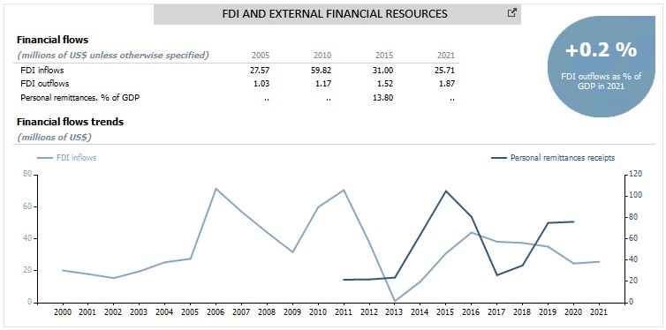
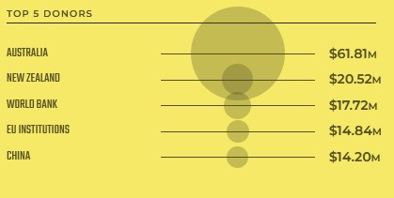

Overseas Development Assistance

45
https://thedocs.worldbank.org/en/doc/794636a11e1a7af4 792f578769aebf37-0070012022/original/Our-Work-in-the-
Pacific-Design-2022-Digital-Single-Page.pdf

Overall, though there have been mixed results on the highs and lows of ODA to Vanuatu in the past 5 years, with 2015 being one lucrative year ($231.69million in overall ODA), the general ODA trend for Vanuatu still presents a somewhat positive outlook. Vanuatu’s situation is not so bad compared to the rest of the Pacific, whereby ODA trend is overall showing a decline. The total ODA for Vanuatu spent for the year 2020 was recorded at USD$161.69m with largest contributions received from Australia, New Zealand and China. Australia alone contributes more than 38% of the top 5 ODA contributors to Vanuatu and is the highest ODA contributor to the Pacific. The contributions below depict a combined ODA value of ODA grants and loans provided through contributions from bilateral and multilateral development partners.
Pacific Aid Map for Vanuatu, 2020 Lowy Institute
46
https://www.adb.org/sites/default/files/publication/27812 /van-2021.pdf
47
https://unctadstat.unctad.org/countryprofile/GeneralProfil e/en-GB/548/index.html

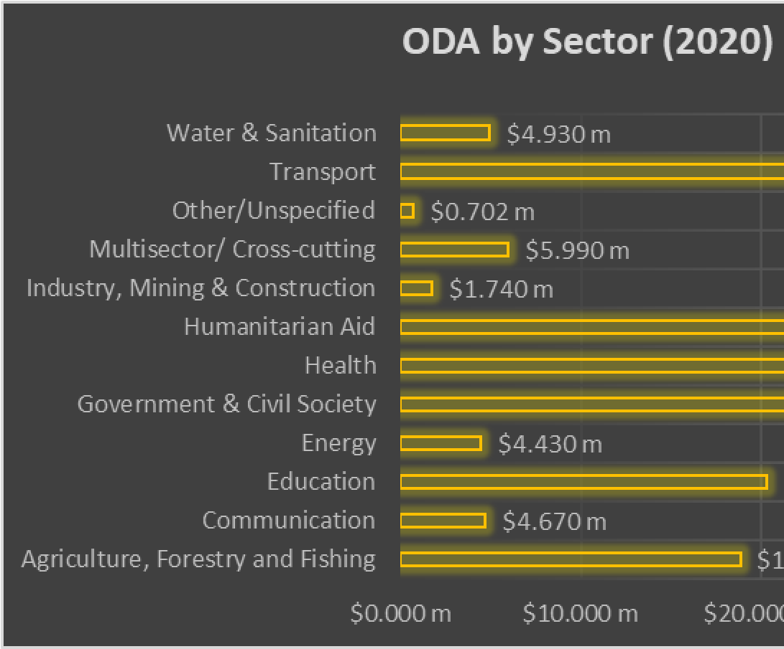
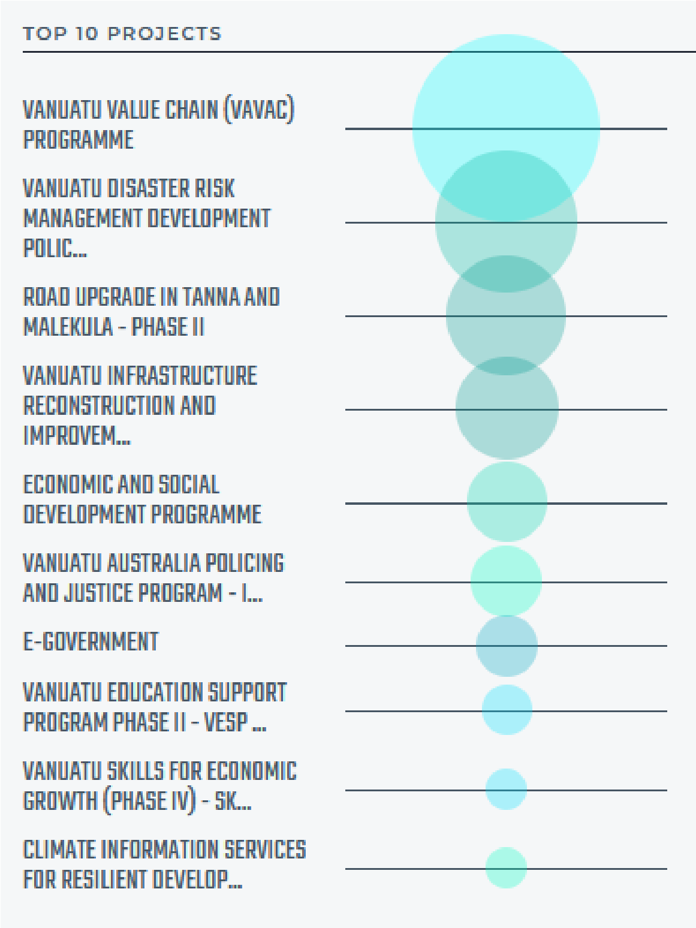
In December 2020, Vanuatu graduated
from
official list of Least Developed Countries (LDC),
becoming the sixth country to achieve the
milestone since the development categorization
was created in 1971.

However, with this
graduation, Vanuatu still remains

volatile to key
development challenges

and to external shocks

facing SIDS, hence, still remains substantially
reliant on international aid assistance.
Vanuatu’s
heavy reliance on remittances and tourism income
which has substantially been impacted by COVI
D
-
19
means it will continue to
need critical
development financing support from external
sources, particular through continued concessional
loans and grants.

Top
10

Projects funded through

ODA

in 20
20

for Vanuatu,
Lowy Institute

Above Chart developed through ODA mapping by Lowy
Institute for Vanuatu (2020)

Annex 1
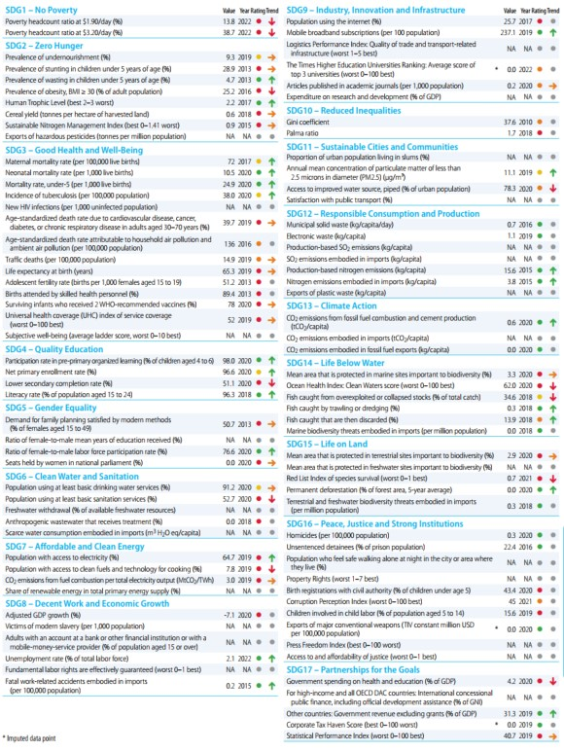
Source: Sustainable Development Report 2022, SDSN.

ADB 2022
COVID-19 Response Gender Working Group. Diverse Voices and Action (DIVA) for Equality Fiji, Fiji Women’s Rights Movement (FWRM), UN Women, the Asian Development Bank and the Ministry of Women, Children and Poverty Alleviation (MWCPA). 2020. Gendered Impacts of COVID-19 on Women in Fiji.
World Bank, Revision of previous estimate, 2022.
Food and Agriculture Organisation (FAO). 2021c. The State of Food Security and Nutrition in the World Report.
Ibid
Food and Agriculture Organisation of the United Nations (FAO). 2021b. Accelerating progress towards SDG2. Policy effectiveness analysis.
Fiji Women’s Rights Movement, 2021
Fiji Women’s Rights Movement. September 2020. Gender Equality, Diversity & Inclusion – Leadership in Fiji Government-Controlled Boards.
Inter-Parliamentary Union (IPU) database. Accessed November 2021.
UNDRR. 2020. Integrating Disaster Risk Reduction and Climate Change Adaptation in the UN Sustainable Development Cooperation Framework. Guidance Note on Using Climate and Disaster Risk Management to Help Build Resilient Societies.
Op. Cit., 37 (a)
International Women´s Development Agency and Fiji Bureau of Statistics. 2017. Exploring Multidimensional Poverty in Fiji. Findings from a Study using the Individual Deprivation Measure. 13
Marine and Coastal Biodiversity Management in Pacific Island Countries (MACBIO) Project with GIZ, IUCN & SPREP. 2015. National Marine Ecosystem Service Valuation: Fiji. Gonzalez, Ricardo; Ram-Bidesi, Vina; Leport, Guillaume; Pascal, Nicolas; Brander, Luke; Fernandes, Leanne; Salcone, Jacob; Seidl, Andrew.
United Nations Conference on Trade and Development (UNCTAD). 2021. Development and Globalization: Facts and Figures. Data on Fiji. https://dgff2021.unctad.org/fiji/
WTTC, 2020
Republic of Fiji. 2020. Key Statistics on Fiji Agriculture Sector. Ministry of Agriculture. Agriculture & Rural Statistics Unit. Economic Planning & Statistics Division.
Gendered Impacts of COVID-19 on Women in Fiji., Op. Cit.
International Labour Organisation (ILO). July 2020. Impact of COVID19 on employment and business in the Pacific: Findings of the Rapid Assessment in Fiji and Samoa.
Ibid, p. 3
United Nations Capital Development Fund (UNCDF). 2021. Digital Economy Assessment Report (Unpublished).
Bündnis Entwicklung Hilft and Ruhr University Bochum – Institute for International Law of Peace and Armed Conflict (IFHV). 2020. WorldRiskReport 2020.
UNDRR, 2019
INFORM is a collaboration of the Inter-Agency Standing Committee Reference Group on Risk, Early Warning and Preparedness and the European Commission. Data are from the INFORM RISK 2022 Release.
Each dimension is scored out of 10 and together they create an overall risk factor.
Republic of Fiji. 2020. National Biodiversity Strategy and Action Plan. Ministry of Waterways and Environment. Department of Environment. P. 16
Climate Vulnerability Assessment, Op. Cit. ²⁸ National Biodiversity Strategy, Op. Cit. [27], p. 26
Climate Vulnerability Assessment, Op. Cit.
Ibid, p. 117
Ibid
National Biodiversity Strategy, Op. Cit., p. 15
Ibidem
ibid
Lee, D., Zhang, H., & Nguyen, C. 2018. The Economic Impact of Natural Disasters in Pacific Island Countries: Adaptation and Preparedness. IMF Working Paper WP/18/108.
International Federation of Red Cross and Red Crescent Societies (IFRC). February 2021. The Disaster Law Programme in Asia Pacific Brief on Leaving No One Behind.
Such as the Pacific Insurance and Climate Adaptation Programme (PICAP) developed by UNCDF, UNU-EHS and UNDP. Intended to become the Pacific and Fiji’s first
Parliament of the Republic of Fiji. 2021. Climate Change Act. Act Nº 43 of 2021.
London School of Economics (LSE). 2021. Fiji Climate Change Act 2021. Climate Change Laws of the World. Grantham Research Institute on Climate Change and the Environment.
or the current 2023 fiscal year, low-income economies are defined as those with a GNI per capita, calculated using the World Bank Atlas method, of $1,085 or less in 2021; lower middle-income economies are those with a GNI per
FAO, IFAD, UNICEF, WFP and WHO. 2021. The State of Food Security and Nutrition in the World 2021. Transforming food systems for food security, improved nutrition and affordable healthy diets for all. https://doi.org/10.4060/cb4474en
International Fund for Agricultural Development (IFAD) and FAO. 3 September 2019. Proposal for GAFSP Financing: Small Islands Food and Water Project (SIFWaP). Project
UNESCO. 2003. Convention for the Safeguarding of the Intangible Cultural Heritage.
Central Statistics Division. 2021. Tuvalu Multiple Indicator Cluster Survey 2019-20. Survey Findings Report.
CEDAW Op. Cit.
ADB Key Indicators, ADB, 2021
UNESCO Institute for Statistics (UIS). http://uis.unesco.org/en/country/tv
Milan A. Op. Cit.
https://data.unwomen.org/country/tuvalu
Milan A. Op. Cit.
Tuvalu Demographic Health Survey 2007, Op. Cit.
Rapid Assessment Op. Cit.
UNICEF. December 2017. Situation Analysis of Children in Tuvalu.
Government of Tuvalu. 2021. Tuvalu Agriculture and Fisheries Report: Based on the Analysis of the 2017 Population and Housing Census. Central Statistics Division (CSD).
Ibid
Bell et al. 2021. Pathways to Sustaining Tuna-dependent Pacific Island Economies during Climate Change. Nature Sustainability.
http://www.sas.com.fj/ocean-law-bulletins/a-nationaloceans-policy-for-tuvalu-3-experts-consider-the-processto-get-there)
Government of Tuvalu. 2021. Multiple Indicator Cluster Survey (MICS). Snapshot Report. Tuvalu Central Statistics Division. United Nations Children’s Fund (UNICEF), United
United Nations Office for Disaster Risk Reduction (UNDRR) and Asian Pacific Development Center (APDC). Disaster Risk Management in Tuvalu. Country Update 2020. (Unpublished)
IMF. 2018. The Economic Impact of Natural Disasters in Pacific Island Countries: Adaptation and Preparedness (IMF 2018). Dongyeol Lee, Huan Zhang, and Chau Nguyen. WP 18/108.
IPCC AR6 Report (2021)
Government of Tuvalu. 2012. Tuvalu National Climate Change Policy 2012-2021. Charting Tuvalu through the Challenges of Climate Change. Ministry of Foreign Affairs, Trade, Tourism, Environment and Labour. SPREP, SPC and UNDP.
NSSD Op. Cit.
Government of Tuvalu. August 2018. Tuvalu National Culture Policy Strategic Plan 2018-2024. UNESCO. Rei Foundation.
UNDRR & APDC, Op. Cit.
Government of Tuvalu. March 2016. Te Kakeega III. National Strategy for Sustainable Development 2016-2020.
UNESCO-IOC
Government of Tuvalu. December 2015. Tuvalu Second National Communication to the UNFCCC. GEF. UNDP.
Government of Tuvalu. November 2015. Intended Nationally Determined Contribution. Tuvalu INDC.
https://www.worldbank.org/en/news/pressrelease/2021/09/02/new-world-bank-group-tuvaluagreement-strengthens-partnership 33 https://unctadstat.unctad.org/countryprofile/GeneralProfil e/en-GB/798/index.html
Least developed countries (LDCs) are low-income countries confronting severe structural impediments to sustainable development. They are highly vulnerable to economic and environmental shocks and have low levels of human assets. There are currently 46 countries on the list of LDCs which is reviewed every three years by the Committee for Development (CDP), a subsidiary body of the UN Economic and Social Council (ECOSOC).
Government of the Republic of Vanuatu. December 2019. Vanuatu Smooth Transition Strategy.
Republic of Vanuatu. 2016. Vanuatu 2030. The People´s Plan. National Sustainable Development Plan 2016 to 2030. Department of Strategic Policy, Planning and Aid Coordination.
VCCDRRP, Op. Cit.
Vanuatu Young Women for Change (VYWC). 2019. Women2030 Monitoring and Review of the Sustainable Development Goals and Development Justice
Committee on the Elimination of Discrimination against Women. 2016.Concluding observations on the combined fourth and fifth periodic reports of Vanuatu.
World Bank. October 2021. Poverty and equity brief: Vanuatu. ⁸ VNR, p. 50
Hardship Survey, Op. Cit.
UN Interagency Group for Child Mortality Estimation (IGME). https://childmortality.org/data/Vanuatu
Republic of Vanuatu. RMNCAH Policy, Strategy and Implementation Plan 2021-2025. August 2021. Draft and unpublished.
Ibid.
VNR, Op. Cit.
Committee on the Elimination of Discrimination against Women. 2016.Concluding observations on the combined fourth and fifth periodic reports of Vanuatu.
Ibid.
Republic of Vanuatu. 2016. Vanuatu 2016 Post TC Pam Mini Census Report. VNSO. Ministry of Finance and Economic Management.
UNICEF and Government of Vanuatu. 2012. Vanuatu Child Poverty and Disparities Report.
Office of the United Nations High Commissioner for Human Rights. November 2018. UPR. Compilation on Vanuatu. Report of the OHCHR. Human Rights Council.
The graph corresponds to the FAO, SPC, VNSO Vanuatu Food Security Profile. 2021. Op. Cit.
FAO Gender Assessment. Op. Cit. ²¹ Food Security Survey. Op. Cit.
Ibid.
World Bank Macro Poverty Outlook 2022
estimates
Well-Being Survey, Op. Cit.
Republic of Vanuatu. 2021. Labour Market Monograph. NSDP Baseline Survey. Vanuatu National Statistics Office. Ministry of Finance and Economic Management.
Republic of Vanuatu. March 2015. Vanuatu Post-Disaster Needs Assessment (PDNA). Tropical Cyclone Pam. Prime Minister´s Office. P. 43
Labour Market Monograph, Op. Cit.
Jagannath, Ajay; Narasimhan, Krishnan. 2015. Preparing for the perfect storm Climate Disaster Risk Insurance in Vanuatu. Pacific Financial Inclusion Programme (PFIP). UNCDF and UNDP.
Republic of Vanuatu. May 2016. National Ocean Policy. Our Ocean, Our Culture, Our People. Marine and Coastal
Commonwealth Marine Economics Programme. 2018. Enabling safe and sustainable marine economies across Commonwealth Small Island Developing States. Vanuatu Country review. Centre for Fisheries and Aquaculture Science. UK Hydrographic Office. National Oceanography Centre. Foreign & Commonwealth Office.
Republic of Vanuatu. November 2012. Vanuatu National Youth Development Policy (VNYDP) 2012-2022 and Strategic Plan of Action 2012-2022. Ministry of Youth Development, Sport and Training
Bündnis Entwicklung Hilft. 2020. World Risk Report.
Country Risk Profile: Vanuatu. Pacific Catastrophe Risk Assessment and Financing Initiative, 2011. file:///C:/Users/User/Downloads/PCRAFI%20AIR%20Broc hure-%20Vanuatu.pdf
Lee, Dongyeol; Zhang, Huan; Nguyen, Chau. 2018. The Economic Impact of Natural Disasters in Pacific Island
Republic of Vanuatu. 2016. Vanuatu Climate Change and Disaster Risk Reduction Policy 2016-2030 (VCCDRRP).
The Vanuatu Climate Change and Disaster Risk Finance Assessment and the Vanuatu National Policy on Climate Change and Disaster-Induced Displacement. 2018.
Metric Tonnes of Carbon Dioxide Equivalent
FAO Code of Conduct for Responsible Fisheries (CCRF) Survey
Republic of Vanuatu. May 2016. National Ocean Policy. Our Ocean, Our Culture, Our People. Marine and Coastal
Pascal, Nicolas; Leport, Guillaume; Molisa, Vatu; Wendt, Hans; Brander, Luke; Fernandes, Leanne; Salcone, Jacob; Seidl, Andrew. 2015. National Marine Ecosystem Service Valuation: Vanuatu. MACBIO.
Commonwealth Marine Economics Programme. 2018. Enabling safe and sustainable marine economies across Commonwealth Small Island Developing States. Vanuatu Country review. Centre for Fisheries and Aquaculture Science. UK Hydrographic Office. National Oceanography Centre. Foreign & Commonwealth Office.

